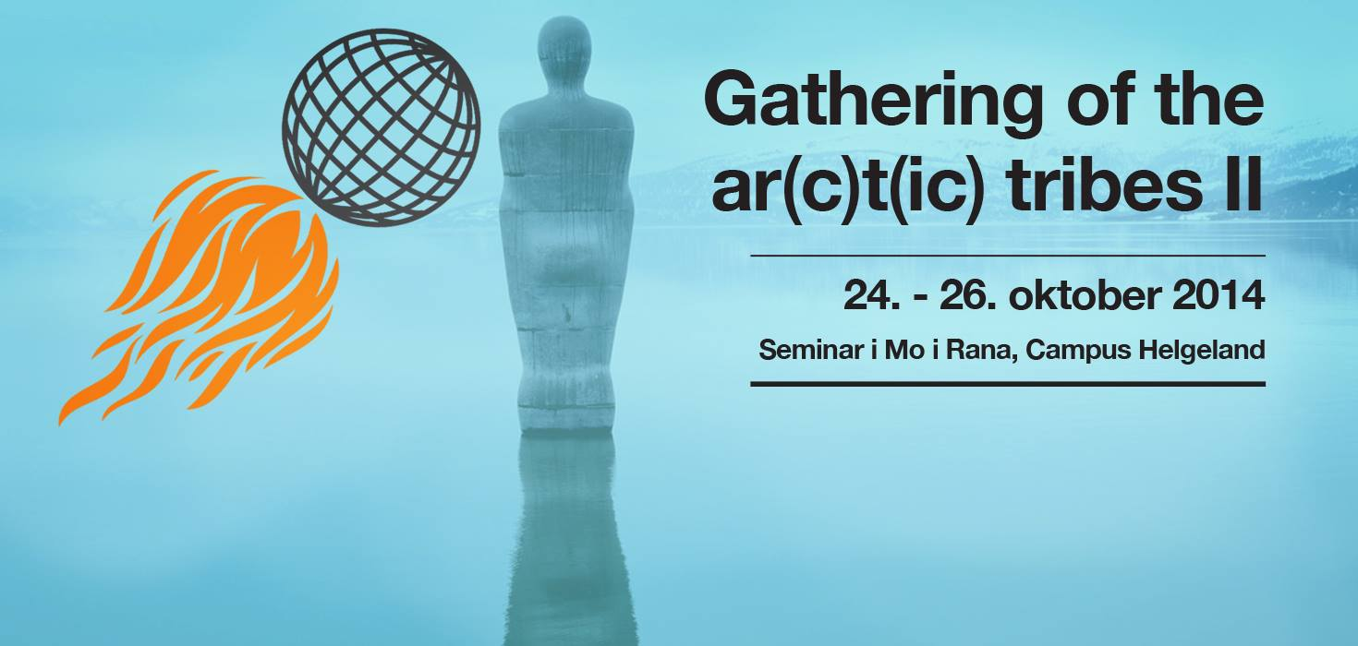
Program
Day 1 Friday
15:15 – 16:00
Registration and coffee
Moderator: Kristoffer Dolmen
16:00 – 16:15
Welcome/Introduction
Madeleine Park
16:15 – 17:00
Urban development and social change, Mo i Rana and the Nordland Region - A Historical Perspective
Harald Rinde
16:00 – 17:45
"What´s he building in there"
Hans-Petter Bjørnådal

17:45 – 18:00
Short break
18:00 – 18:45
"In the National Museum’s Blind Spot". When art becomes action, what’s the collection worth then?
Samir M´Kadmi
18:45 – 20:00
Visit to Rana museum and the exhibition: "In the National Museum’s Blind Spot"
Introduction to the exhibition, Samir M´Kadmi
Drinks and snacks
20:30 – 22:00
Dinner
For speakers and those who have signed up

Day 2 Saturday
09:30 – 10:00
Registration and coffee
Moderator: Eva Bakkeslett
10:00 – 10:45
On subjects and societies: Socially engaged art: whom, exactly, does it want to engage?
Elena Trubina
10:45 – 11:30
Presentation of the project russianmarket.info
Hilde Methi
11:30 – 11:45
Short break
11:45 – 12:30
How can artists merge with existing political movements without losing their art - and does it matter? What is an avantgarde position today?
Marius von der Fehr
12:30 – 13:30
Lunch, Campus Helgeland
13:30 – 14:30
Brothers and Sisters in Arms, Art and Activism. The question of participation and subject in collective practice, collaboration and community.
Alexander Nikolic
14:30 – 15:15
Art in public spaces in today's Russia: how social practice in art becomes political action
Anna Bitkina and Maria Veits
15:15 – 15:30
Short break
15:30 – 16.15
10 working points for artists in new divisions of labour
Florian Schneider
16:15 – 17:00
Panel discussion.
End of session at Campus for the day
19:00 – 19:55
"Beyond Horizons", video screening
Curated by: Hanne Hammer Stien. Introduction to the program by Ivar Smedstad
Where: Meyergården hotel, auditorium
20:00 – 22:30
Gathering – dinner
Meyergården hotel, restaurant. All participants.

Day 3 Sunday
10:45 – 11:00
Registration and coffee
Moderator: Eva Bakkeslett
11:00 – 11:45
Cities as anthroposcenes and urban resilience
Sacha Kagan, keynote speaker
11:45 – 12:30
The case of S.a.L.E-Docks and the reappropriation of the cultural commons in Venice
Marco Baravalle
12:30 – 12:45
Short break
12:45 – 13.30
The role of culture in city development. New Urban Topologies and Stockholm on the Move
Johanna Brattel
13:30 – 14:30
Lunch, Campus Helgeland
14:30 – 15:15
The permeable limits of public space, case-studies from Romania
Raluca Voinea
15:15 – 16:00
Art as an agent of social change, Experiences from the project LevArt
Anne-Gro Erikstad
16:00 – 16:30
Summary and conclusion
_________________________________________________________________________________
Video Screening
Terra Nullius part II by Siri Hermansen, 2014, 14:17, color, stereo.

Hollow Earth (Harstad) by Emilija Skarnulyte/Tanya Busse, 2013, 22:27, color, stereo (10 min excerpt).

The Right to the Land and the Water by Geir Tore Holm, 2010/11, 14:19, color, stereo.

Curator: Hanne Hammer Stien. Produsent: Ivar Smedstad, Atelier Nord. Part of the project: "Beyond Horizons".
In the National Museum’s Blind Spot
When art becomes action, what’s the collection worth then?
Participating artists: Nicoline van Harskamp, Farhad Kalantary, Andrea Lange, Mobile Kultur Byrå (Kirsten Dufour, Hilde Methi og Ulrike Solbrig), Selma og Sofiane Ouissi, SEX TAGS (Stefan og Peter Mitterer), Steirischer Herbst Festival. Curator: Samir M’kadmi
The exhibition provides a topical and informative insight into socially engaged art. It brings together videos, websites, props and printed materials to document seven projects in which artists have placed their creative energies at the service of strong social convictions. The artists use their personal democratic rights to fight for a society that protects the rights of all. The exhibition introduces visitors to meaningful campaigns and processes, inviting them to reflect on the role and function of art and the artist in society, and to become active themselves. The best celebration of the constitution of 1814 is for people to use the freedom of expression and other basic rights it grants them. The exhibition is a collaboration between the National Museum and TrAP, as part of the celebrations marking the bicentennial of Norway’s constitution.

