GLOBAL FORUM FOR CULTURE AND SUSTAINABLE DEVELOPMENT

Background: Culture|Futures is a global network of cultural actors and institutions seeking to develop new daily practices in building a sustainable future in cities and regions around the world. Culture|Futures has organized 7 conferences on 5 continents on this agenda in the latest year. Culture|Futures has Dr. R. Pachauri as its global patron, and has its secretariat in Copenhagen, Denmark.

Aim: The focus of the forum will be on how large cities/regions and cultural institutions/creative economy can collaborate on the green agenda, and on establishing common, open source modelling and measuring tools, benchmarks as well as demonstrators and leadership for such cooperation. In addition a number of exemplary cases and experiences are shared.

Venue:
Galpão da Cidadania
Av. Barão de Tefé, 75 - Saúde
Rio de Janeiro - RJ, 20220-460, Brasil

Program: June 17th 2012

9.00 Official Opening
Dr. Rajendra Pachauri* (India), Chair of Intergovernmental Panel on Climate Change, DG TERI, and Patron of CultureFutures
Nicolaj Prytz, Consul General, Embassy of Denmark in Brazil

9.30 Integrating sustainability into daily practices of cultural institutions:
Olaf Gerlach-Hansen (Denmark), Director, Culture|Futures
Recommendations and lessons learned from dialogues with cultural institutions in Asia, Europe, Brazil, South Africa and North America

10.00 Large scale regional eco-demonstrators linking green growth and culture
Peter Head (UK), Executive Chair of the Ecological Sequestration Trust:
Launch of demonstrators initiated in India, China and Rwanda/Africa as private-public partnerships in 2012: Benchmarks, common modelling and measuring tools, open source approach, and wider international implications for business, regions, creative sector and green growth.

Q&A

11.00 Regional and global perspectives on Eco-demonstrators around the world
Shanfeng Dong* (China), General Manager, Bluepath City Consulting. Representatives from Africa and India and possibly others. Panel facilitated by the Ecological Sequestration Trust.

11.45 Co-creating the story of the pathway to sustainability around the world
Filmmaker John D. Liu (China/US), Director, Environmental Education Media Project (EEMP), and Senior Research Fellow, IUCN Netherlands. John showcases his research, his latest FILM and the new Television Series and Website, “What if we Change?”

12.30 Lunch

13.30 Panel of Cases of Creative Eco-Leadership
- Art Education: Case of CICLO pilot project for UNESCOs Art Education Week: Lêda Fonseca, Cultural Secretariat of City of Rio de Janeiro
- Sustainable living/culture – the case of Denmark: Olaf Gerlach-Hansen, Danish Cultural Institute
- Indigenous culture/Inuit: SILAS – Artist Lana Hansen (Greenland)
- Performing Arts: Case of AMAZONAS opera/Freddy Grunert, ZKM (Germany)

15.00 Closing

* subject to final arrangements.

The programme is subject to change.

Registration for access to program at Galpão da Cidadania at: http://www.cultura.gov.br/riomais20/
(registration system still being set up according to our information)

Please also register to Culture|Futures by sending a mail to lhj@culturefutures.org with your name and organisation and receive programme updates and info.

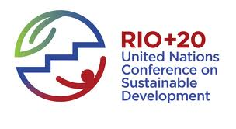

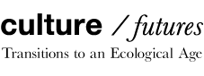
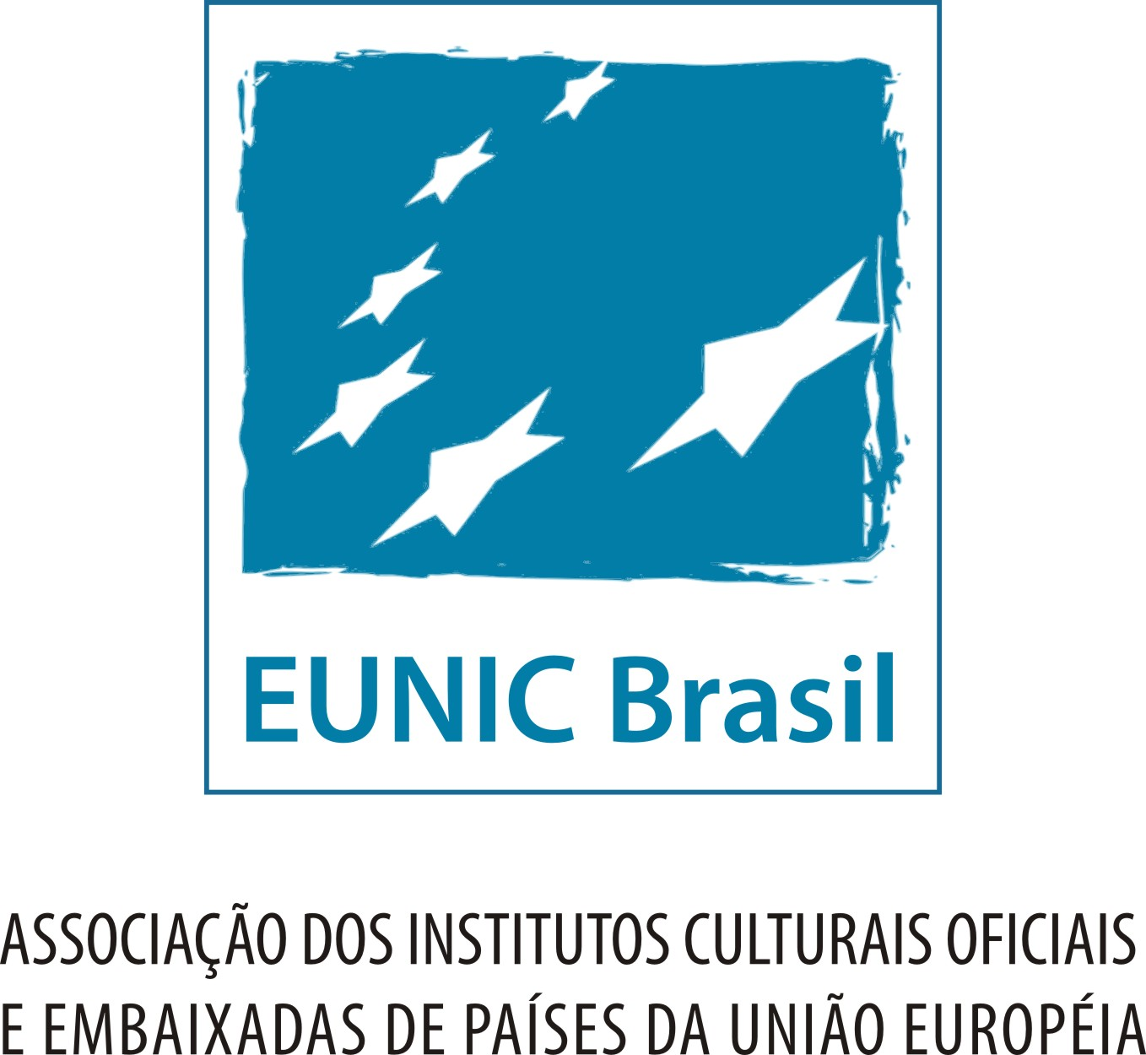 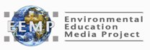 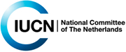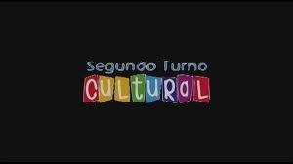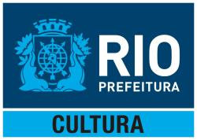 [other partners to be added]

